The School System in the U.S.

Preschool
- Not required by the government, but many parents start their child in preschool between the age of 2-4 years old.
- Most preschools are privately run and prices vary school by school. Currently, there are some government sponsored free preschool programs in Washington for low-income families.

Grade School
(also called K-12, which is pronounced: “K thru Twelve”)
- Required by the government: All children must receive education, but the ages, dates, and requirements vary state by state. Public schools are paid for by the government.
- Within each state, there are School Districts. For example, if you live in Bellevue, you will be in the Bellevue School District. If you live in Kirkland or Redmond, you will probably be in the Lake Washington School District. Each school district must follow the state guidelines, but the districts are able to set their own requirements, curriculum, calendar dates, etc.
- Alternatives to Public School include Private Schools or Homeschooling.

K= Kindergarten: | Children go to Kindergarten at age 5. In Washington, a child must turn 5 by August 31 in order to enter kindergarten.
Elementary School:  Grade 1= first/1st grade  Grade 2= second/2nd grade  Grade 3= third/3rd grade  Grade 4= fourth/4th grade  Grade 5= fifth/ 5th grade | Usually grades 1-5, but some school districts have grades 1-6.  Most children start 1st grade at age 6. In Washington, a child must turn 6 years old by August 31 in order to enter 1st grade. (otherwise, you will need to wait until the following school year to enroll your child)  We call the child a “kindergartner”, a “first-grader”, a “second-grader”, etc.  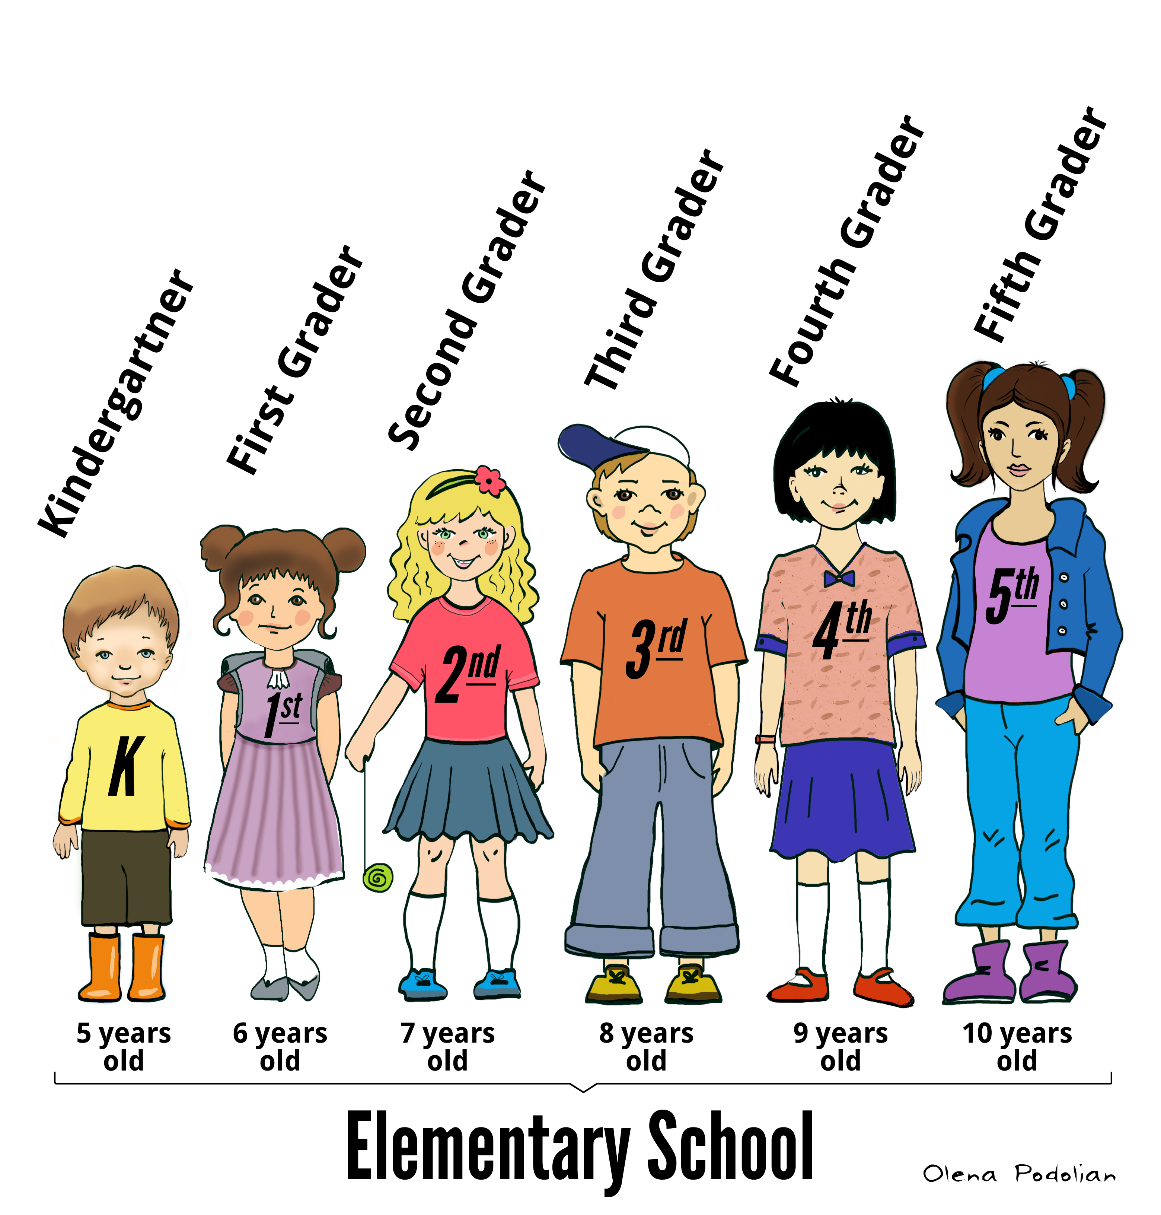
Middle School:  (sometimes called Junior High School)  Grade 6= sixth/ 6th grade  Grade 7= seventh/ 7th grade  Grade 8= eighth/ 8th grade | Usually grades 6-8, but some school districts have grades 7-8 or 7-9.  Children enter Middle School after Elementary School, usually around age 11 or 12.  Beginning in Middle School, students receive grade reports with letters to show their academic progress: A, B, C, D, or F  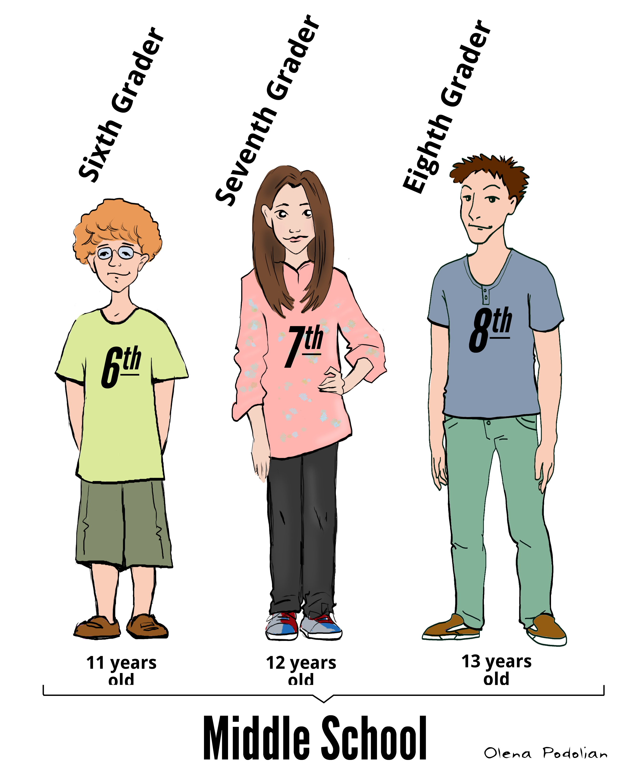
High School:  (sometimes called Senior High School)  Grade 9= Ninth/9th grade  Grade 10= Tenth/10th grade  Grade 11= Eleventh/11th grade  Grade 12= Twelfth/12th grade | Usually grades 9-12, but some districts have grades 10-12.  Children enter High School after Middle School, usually around age 14 or 15.  9th grade= Freshman Year  10th grade= Sophomore Year  11th grade= Junior Year  12th grade= Senior Year  We call the students: a freshman, a sophomore, a junior, or a senior.  Students graduate from high school after they complete their senior year, usually around 18 years old.  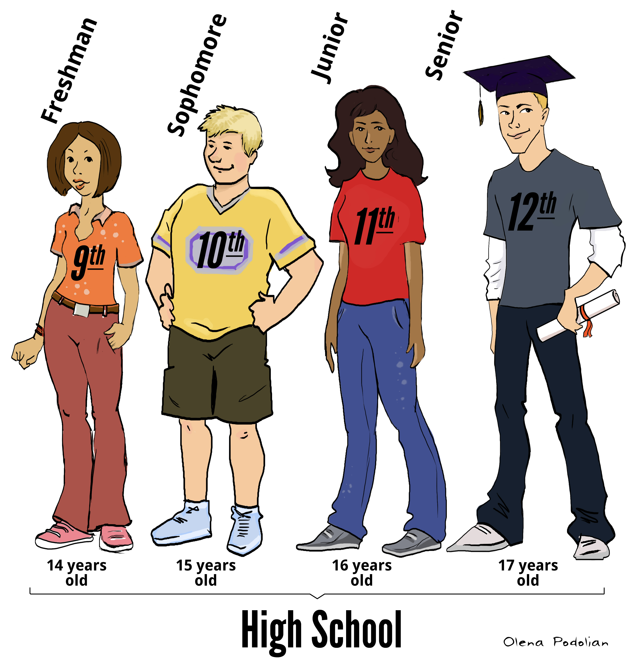

Colleges and Universities
The words college and university can be confusing. In the U.S. we use the word "college" to refer to all higher education after high school, including universities. So, we say "I'm going to college next year" or "Where are you going to college?" or "He's off to college in the fall" when, in fact, the person is headed to a University. I would say: "My son is going to college next year. He's going to the University of Denver."

Information about applying to college:

- During senior year of high school, students can apply to college. Applications usually require: personal information, GPA, transcripts showing all classes taken and grades received, college-entrance exam scores (ACT or SAT exams), essays, letters of recommendation, and lists of extra-curricular and volunteer activities.
- In the U.S., colleges and universities like to see a “well-rounded” student. This means they don’t just look at grades and test scores. Colleges and Universities also want students who participate in sports, dance, music, drama, art, community service, and more. These activities are called “extra-curricular activities” and they are very important for students who would like to attend college in the U.S.

- College is not free in the U.S. and it can be extremely expensive. Many people begin saving for their child’s college education soon after their child is born. There are college savings plans called 529’s that you might want to look into, if you would like to save for your child’s college education.
- Students can also receive financial aid in the form of loans, grants, and scholarships.

Community Colleges:  Degree: Associate’s Degree | Two-year preparatory colleges.  Community Colleges have government funding, so they are more affordable
Colleges and Universities:  Undergraduate Studies  Degree: Bachelor’s Degree | Four-year degree programs.  State Schools are partially government funded, so the tuition is less than a private or out-of-state school.  Out-of-State Schools or Private schools are the most expensive.
Colleges and Universities:  Graduate Studies  Degree: Master’s Degree, PhD, MD (Medical Doctor), JD (Juris Doctor- lawyer) | Programs of further study after a Bachelor’s Degree is received.  Length of time varies depending on the program of study.

